

Assignment-4

CSE1002 OOP with C++



July 10, 2021

Bimal parajuli

20BDS0405

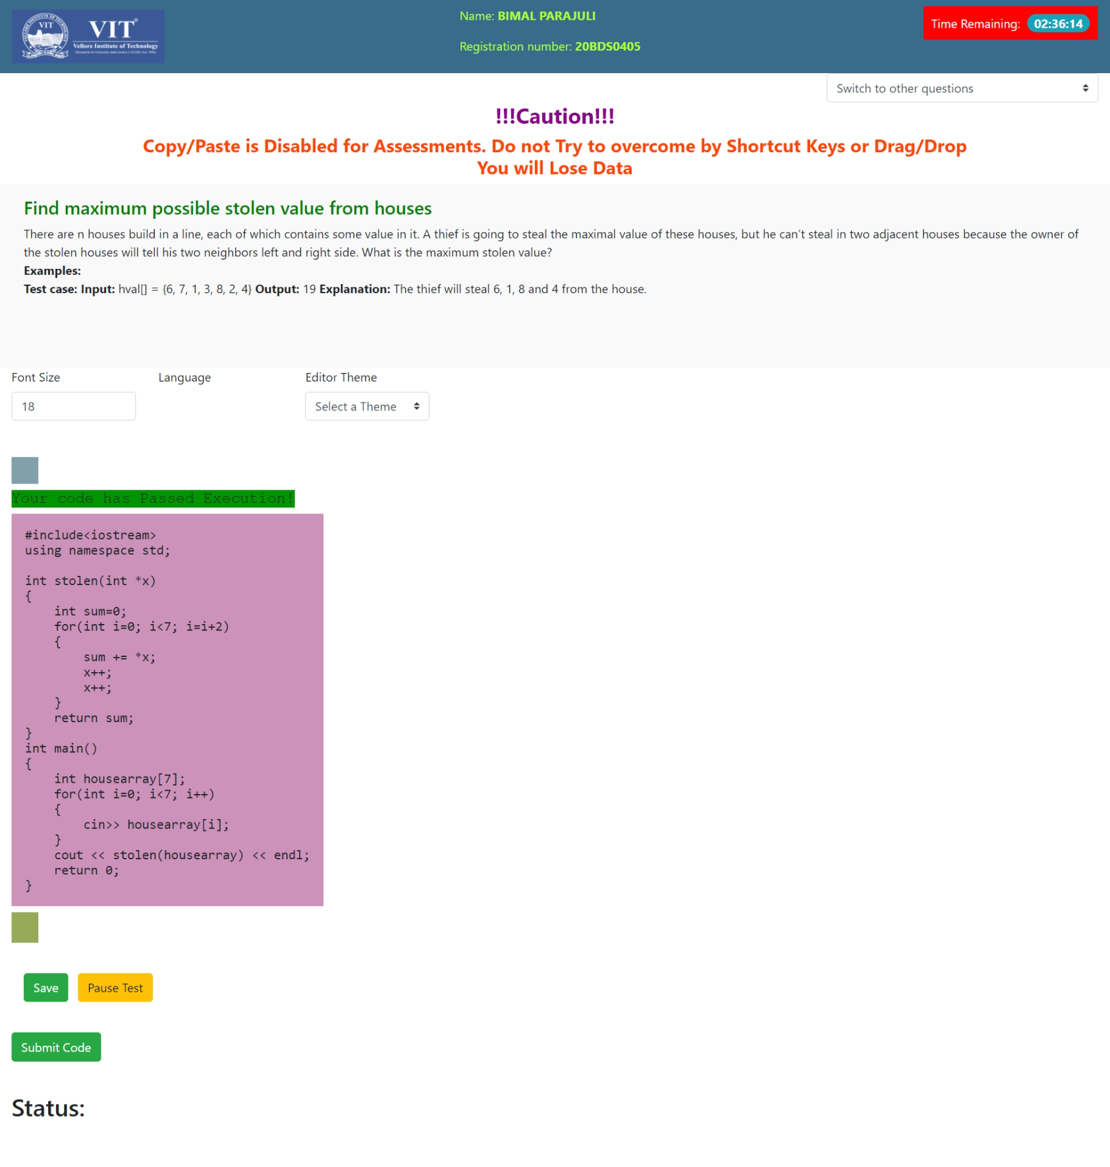

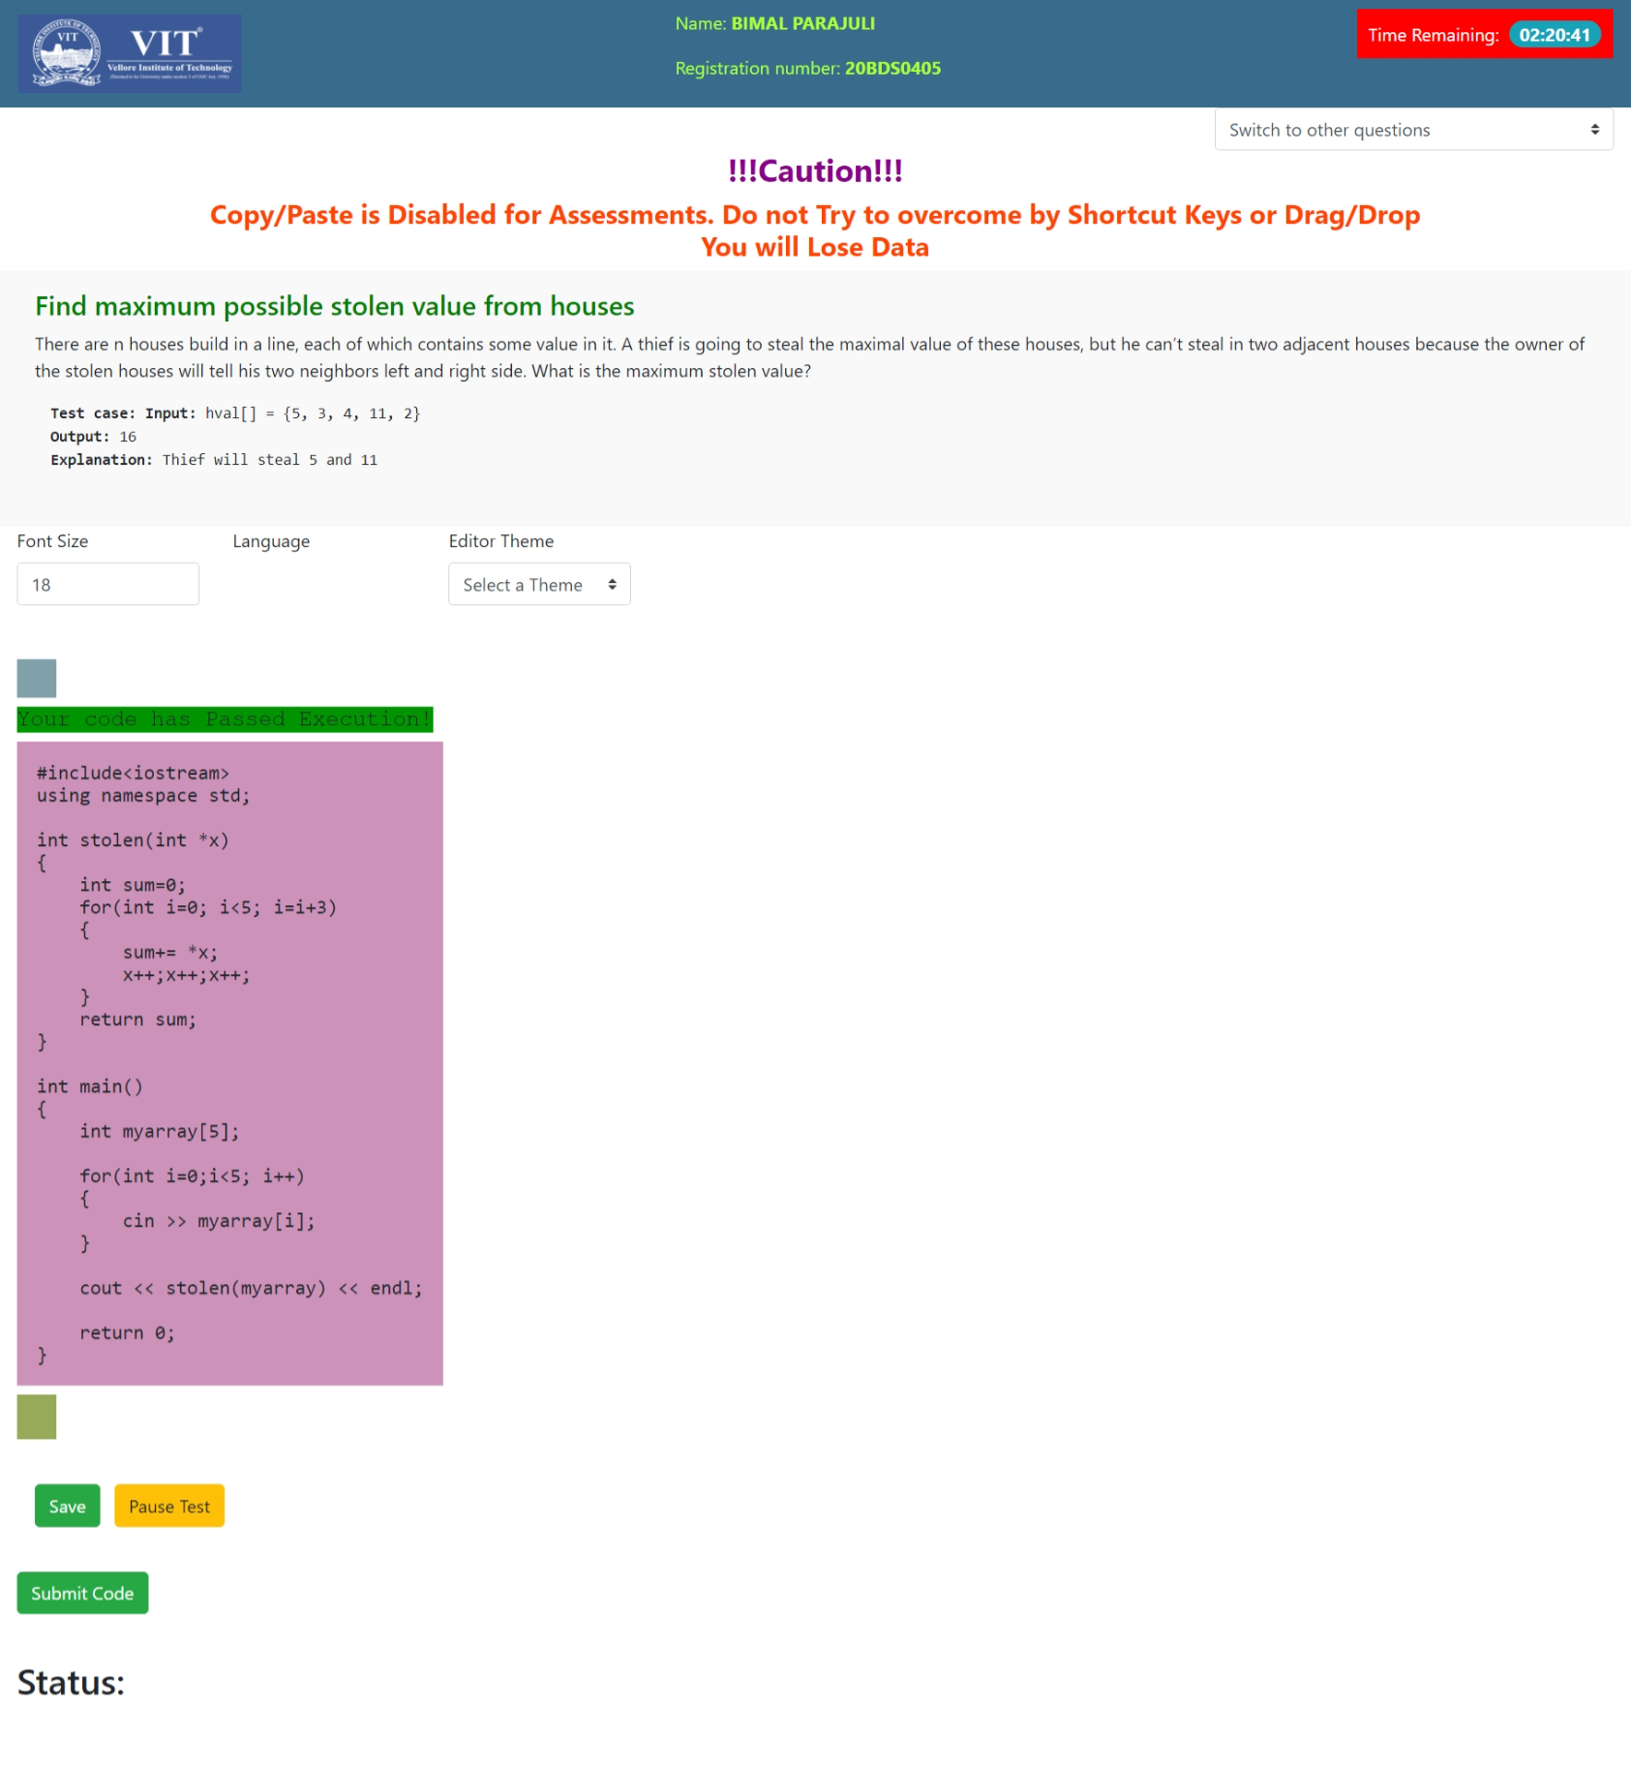

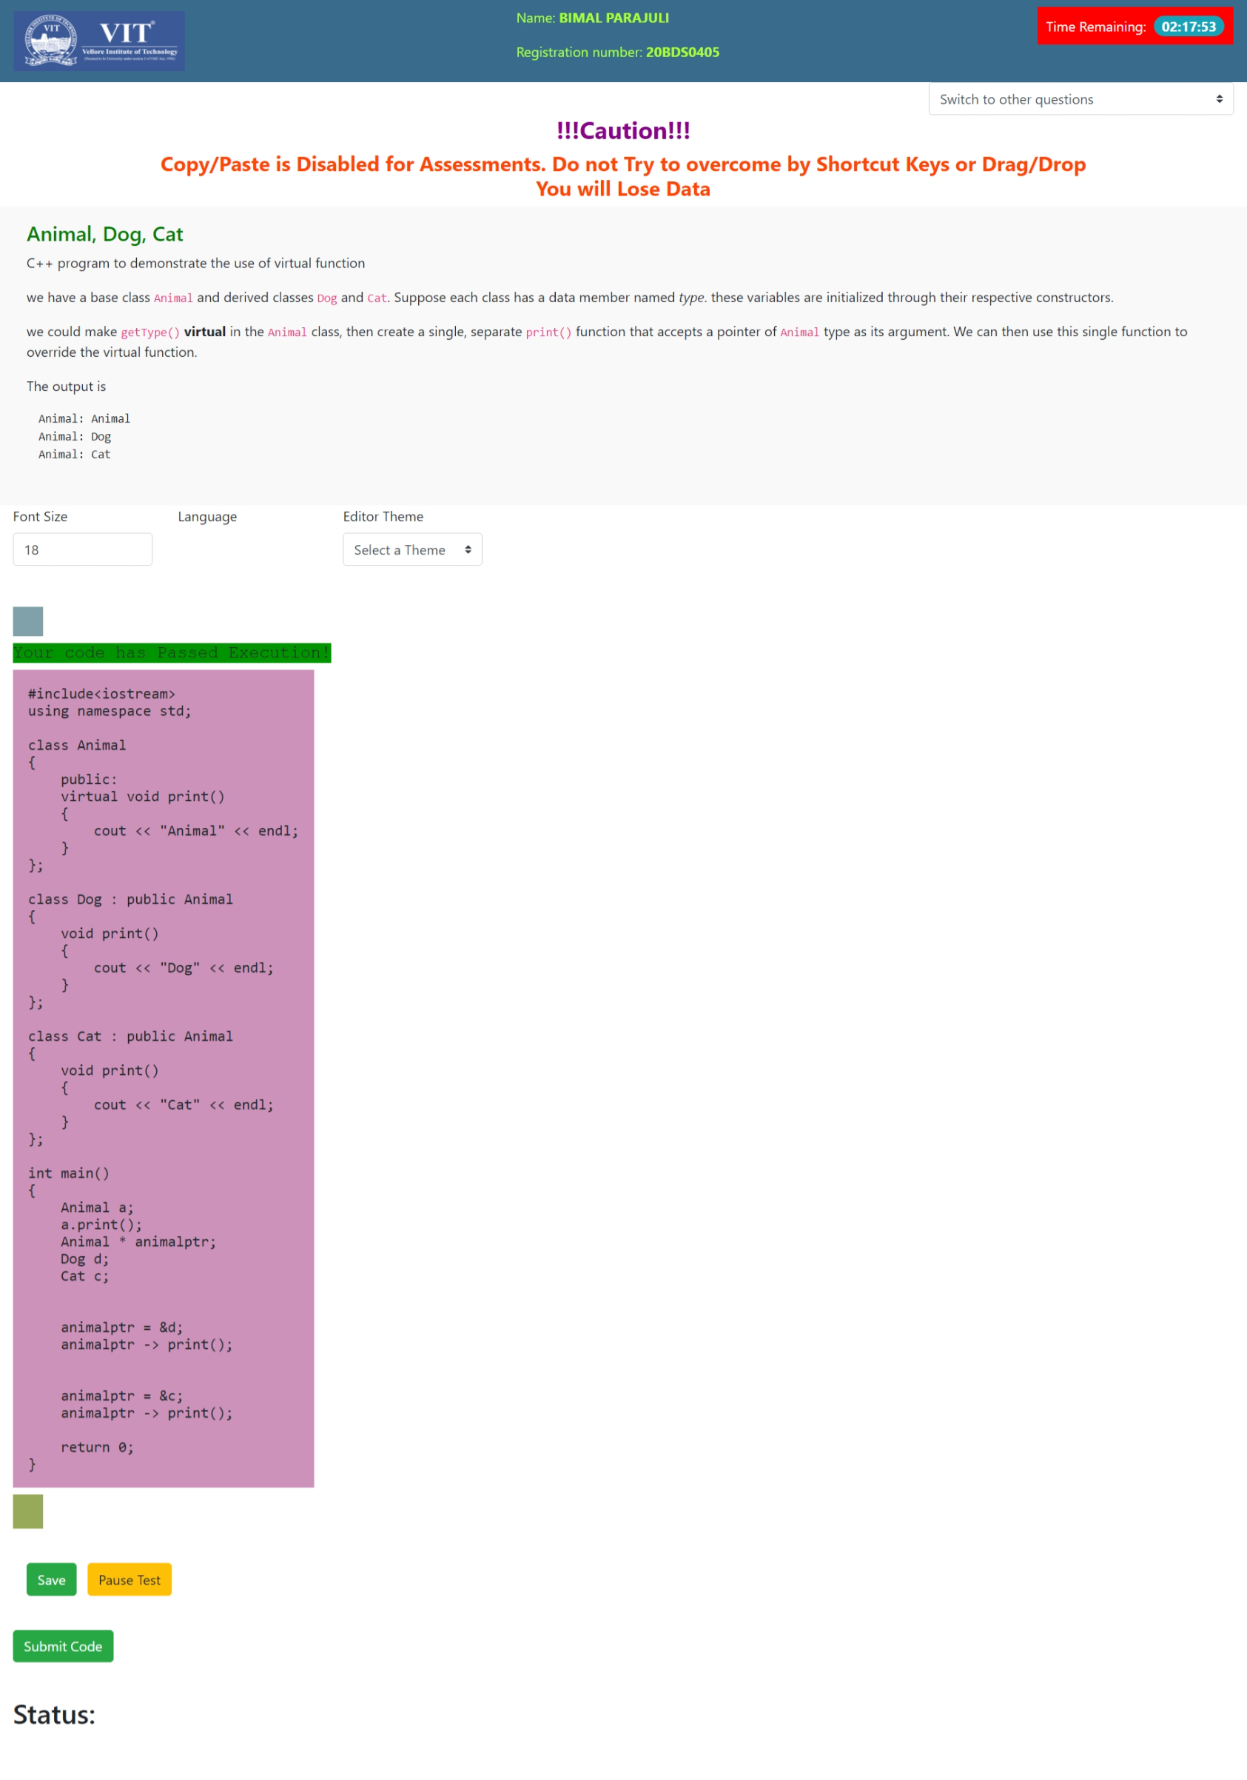

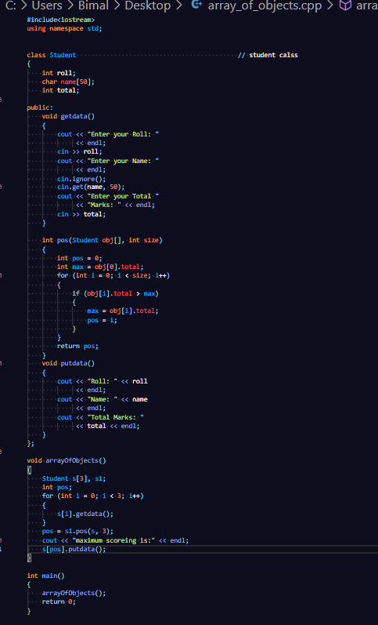

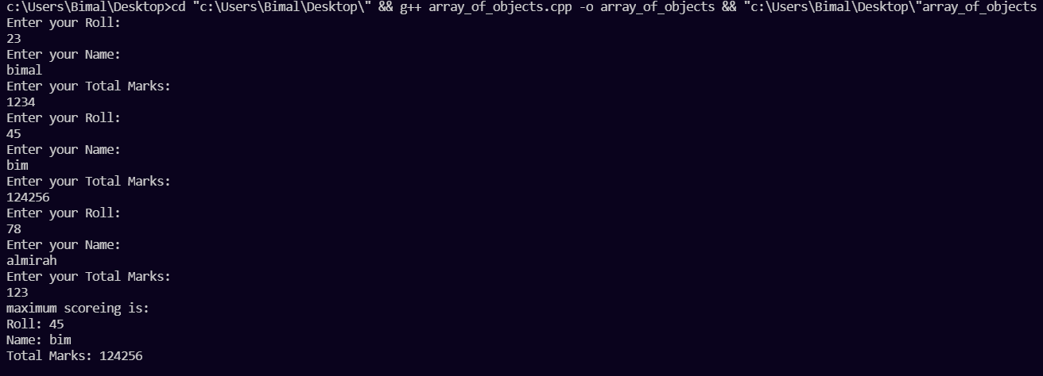

Exception handling:

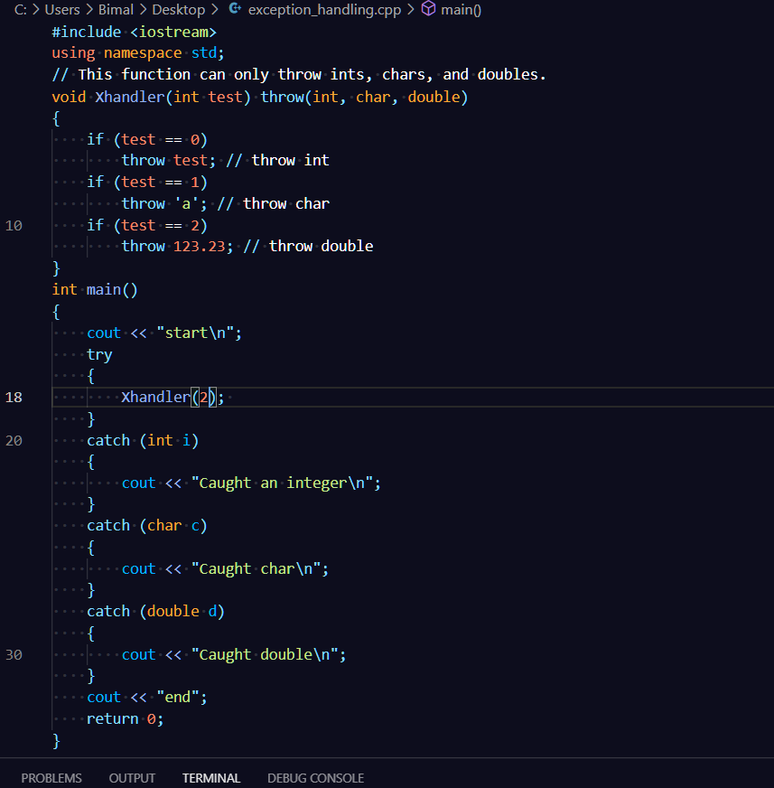

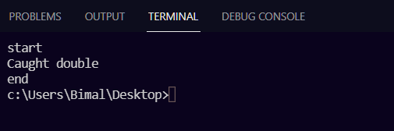

Pure Virtual Functions:

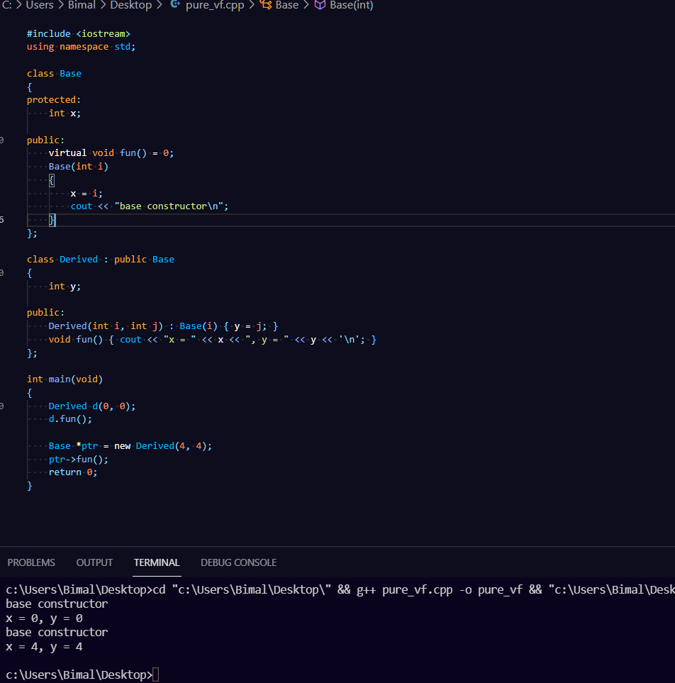

Only Vpropel problems attached here.

Other practice problems:

[bimal-parajuli/c_cpp at master (github.com)](https://github.com/bimal-parajuli/class_assignments_C_Cpp/tree/master)

remaining codes will be updated by tomorrow in master branch.